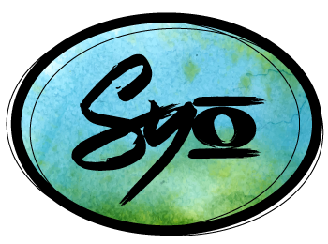
2023 SYO Sponsorship
Would you like to sponsor SYO by purchasing ad space in our concert programs?

Benefits of Advertising:
Reach a targeted audience of families with middle-school, high-school, and college-aged students.
Individual names, corporate logos, and/or advertisements are printed in our summer concert programs.
SYO is a 501c3 non-profit organization through the IRS. All donations made to SYO are tax-deductible to the extent allowed by law.

Meet our audience:
SYO has 2-3 concerts a year with a total audience of approximately 1,000 people. Our program averages between 60 - 100 middle-school, high-school, and college-aged per season.

With your support:
SYO hires professional musicians and educators, including members of the Indianapolis Symphony Orchestra and college professors, provides modest stipends to our interns, purchases equipment and sheet music, commissions original pieces of music, offers tuition assistance and waivers for students with a financial need, provides scholarships for performance tours for students with a financial need, and provides professional training for SYO interns and staff.

In-Kind Donations:
We also accept in-kind donations of gift cards and items for our annual silent auction. Please contact syoindy@gmail.com with questions regarding appropriate donations.

How to select ad size / donation amount:
The six different advertisement size options are listed below. Please select your desired advertisement size under Selection.

Payment information:
Please remit this form and monetary donations to: SYO / 11614 Presidio Drive / Indianapolis, IN 46235
or submit this form and your company logo online to syoindy@gmail.com, and pay online via the Pay-Pal Donation Link on our website homepage, www.syogi.org/donations. Please include your company name in the memo.

Thank you for your support!

Please select your advertisement size:

Selection | Sponsor Level | Ad Size | Page Measurements | Cost | Color
 | Conductor’s Circle Season Sponsor | 2-page insert*  *includes logo and “SYO Presented by (your company name)” on Website, program shirts, & all printed materials, mention from stage | 9” w x 7.75” h | $2,500 | Color*  *Website logo is in color,  shirt logo is B/W
 | Fermata Sponsor | 2-page insert*  *includes logo on Website  & program shirts, mention from stage | 9” w x 7.75” h | $1000 | Color*  *Website logo is in color,  shirt logo is B/W
 | Legato Sponsor | Full Page*  *includes logo on Website | 4.5” w x 7.75” h | $500 | B/W*  *Website logo is in color
 | Marcato Sponsor | Half Page | 4.5” w x 3.75” h | $260 | B/W
 | Accent Sponsor | Quarter Page | 2.25” w x 3.7” h | $130 | B/W
 | Staccato Sponsor | Eighth Page | 2.25” w x 1.875”h | $75 | B/W

Concert Program Advertising Forms and Donations are Due June 24th, 2023.

Please send art to syoindy@gmail.com. JPEG is the preferred format.
Please contact us with any issues or questions 317-869-8498.

Contact Name _____________________________ Company Name _____________________________

Billing Address _________________________________________________________________________

City ______________________________________ State __________ Zip _________________________

Telephone _______________________________ E-mail ______________________________________

